

**Auchinleck Talbot Football Club**

**Beechwood Park**

**Beechwood Avenue, Auchinleck**

**Child Wellbeing and Protection Policy**

|  |  |
| --- | --- |
| **Version Control** | **1** |
| **Date of Implementation** | **25/10/2023** |
| **Date of Review** | **October 2024** |
| **Authorised By** | **C.Peden** |

Contents

**Introduction** 3

**Auchinleck Talbot Football Club - Child Wellbeing and Protection Policy** 3

**Inclusive** 4

**Approachable** 4

Empowering 4

**Accountable** 4

**Overarching vision** 4

**Our Mission** 4

**Definitions** 4

**Definition of Adult** 5

**Definition of Child Abuse** 5

**Definition of Safeguarding** 5

**Definition of Child Protection** 5

**Children’s Wellbeing in Scotland** 5

**Wellbeing Concern** 6

**Risks to Children’s Wellbeing in Scottish Football** 6

**Increased vulnerability** 7

**Children and young people who are deaf and disabled** 7

**Children and young people from black and ethnic communities** 7

**Children in elite football** 8

**Everyone’s Responsibility** 8

**Review** 9

# **Introduction**

Auchinleck Talbot Football Club is a Scottish football club based in Auchinleck, East Ayrshire. Auchinleck Talbot currently play in the West of Scotland League Premier Division. The club is also a member of the Scottish Junior Football Association, and have won the Scottish Junior Cup on a record 14 occasions.

Auchinleck Talbot Football Club are committed to good practice, which protects the wellbeing of children.

All club officials and volunteers in Auchinleck Talbot football club accept and recognise our responsibilities to develop awareness of any issues.

# **Auchinleck Talbot Football Club - Child Wellbeing and Protection Policy**

This document has been developed following best practice guidance and assistance from the

Scottish FA. The document contains sections provided by the SFA, which SFA member clubs must adopt. It covers all activities undertaken involving Auchinleck Talbot youth players in all age groups and players aged under 18 involved in the first team squad.

ATFC recognise and work within the general principles of the United Nations Convention on the Rights of the Child (UNCRC) for the best interests of the child, non-discrimination, participation as well as survival and development.

For the purposes of this policy, a child is defined as someone under the age of 18 years. This policy applies to all children regardless of age, gender, sexual orientation, disability, race, religion, socio-economic status or family circumstance.

Auchinleck Talbot Football Club will:

* Respect the rights of children as paramount.
* Provide opportunities for every interested child to play football to gain a positive experience.
* Include and involve children in decision-making, providing opportunities for children to be heard.
* Promote and implement policies and procedures to safeguard the wellbeing of children and protect them from abuse, ensuring they know what to do and whom they can speak to if they need help.
* Promote and implement policies and guidelines to prevent and respond to bullying, ensuring they know what to do and whom they can speak to if they need help.
* Require members of staff and volunteers to adopt and abide by this policy.
* Train, support and supervise its members of staff and volunteers to adopt best practice in embedding children’s rights in Scottish football and promoting, protecting and respecting these rights to children.
* Respond to any concerns raised where a child’s rights are being denied in Scottish football.
* Regularly monitor and evaluate the implementation of this policy, these procedures and associated safeguards in developing our child-rights based approach and include children’s views in this process.

# **Inclusive**

Football is for everyone, irrespective of background. We celebrate what makes us unique and embrace our differences. We create a culture where rights are respected and everyone is treated fairly, with dignity and respect

# **Approachable**

We are visible, accessible, open and caring. We build respectful and supportive relationships, listening to children’s voices, and championing their views in everything we do

# **Empowering**

We are forward facing and strive to be the best for children and young people.

We are brave, challenging ourselves and others to continually strive for the best outcomes for children and young people. We encourage and support children and young people to express their views.

# **Accountable**

We accept responsibility and take ownership of the wellbeing and protection of children in our game. Our collective leadership calls upon integrity, consistency and confidence in our everyday behaviours.

# **Overarching vision**

Auchinleck Talbot Football club’s vision is forchildren to flourish because we put their safety, wellbeing, rights and enjoyment at the heart of every level of Scottish football.

# **Our Mission**

Children are the club’s priority. We lead with confidence taking responsibility to create a culture of safety and wellbeing. We empower children through active promotion of their rights.

# **Definitions**

Definition of the Child Wellbeing and Protection Policy

The Club’s Child Wellbeing and Protection Policy includes:

* Introduction – Overarching Aim, Definitions, Children’s Wellbeing in Scotland, Risks to Children’s Wellbeing in Scottish Football, Everyone’s Responsibility and Review
* Policy Statement
* Set the Standards – Behaviours, Expectations and Requirements
* Procedures – Appointment and Selection, Responding to Concerns and Case Review
* All associated Practice Notes

# **Definition of Adult**

For the purpose of this policy, an “adult” is any individual aged 18 and over or any individual under the age of 18 years old but who is in a ‘position of trust’.

# **Definition of Child Abuse**

Child abuse is the act or omission that harms a child or young person.

An individual may abuse a child or young person directly, or may indirectly be responsible for abuse because they fail to prevent another person from harming that child or young person, or their inaction leads to harm or the risk of harm. Abuse can be physical, emotional, sexual or by neglect. Abuse can take place in person or online. Although typically thought of as when an adult is mistreating a child or young person, children and young people can also be perpetrators of abuse against other children or young people.

# **Definition of Safeguarding**

Safeguarding is taking action to ensure that all children and young people are safe from harm when involved in football. It means proactively doing everything possible to minimise risk and prevent abuse of children and young people.

# **Definition of Child Protection**

Child protection refers to the actions in response to a specific concern for a child or young person who is at risk or suffering from abuse. Child protection is an essential part of safeguarding if there is a concern that a child or young person is being abused or their safety is compromised.

# **Children’s Wellbeing in Scotland**

Getting It Right for Every Child

The Scottish Government’s Getting It Right for Every Child (GIRFEC [Link GIRFEC](https://www.gov.scot/policies/girfec/) ) is based on children’s rights, and its principles reflect the United Nations Convention on the Rights of the Child (UNCRC). The GIRFEC approach is child focused, based on an understanding of the wellbeing of a child or young person in their current situation, and based on tackling needs early in a collective way. As part of the Children and Young People (Scotland) Act 2014, the concept of wellbeing and the GIRFEC approach is now enshrined in law in Scotland.

The GIRFEC approach supports children and young people so that they can grow up feeling loved, safe and respected, and can realise their full potential. Children and young people should be, Safe, Healthy, Achieving, Nurtured, Active, Respected, Responsible, Included.

These are the eight wellbeing factors are commonly known as SHANARRI Indicators.

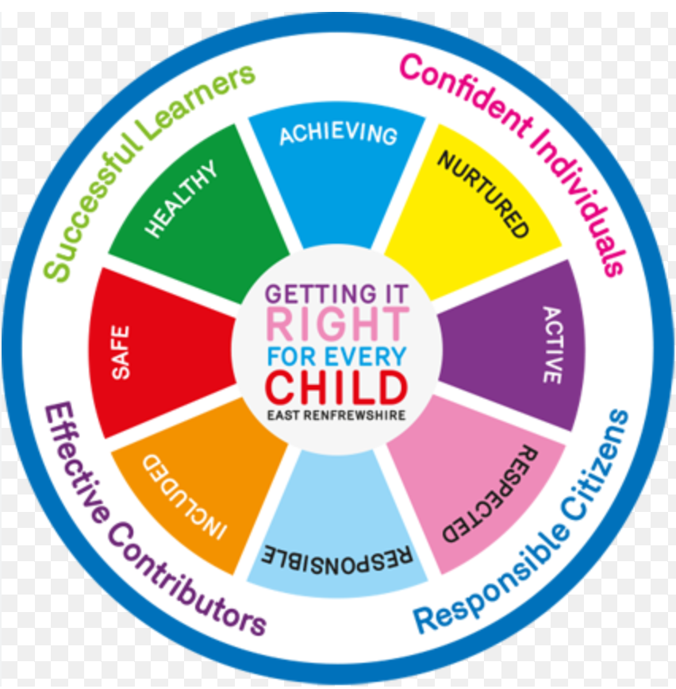

# **Wellbeing Concern**

A wellbeing concern is if a child’s wellbeing (measured using the 8 SHANARRI indicators above) is, or is at risk of being, adversely affected.

A range of experiences can have a negative impact on children and young people. These can range from harmful or abusive behaviour to a family bereavement or social economic factors, such as poverty. The nature of a wellbeing concern will influence how to support the child or young person.

Behaviour, which is abusive or neglectful and is, or is likely to cause harm, will often be referred to as a ‘child protection concern’. Regardless of whether a concern is a wellbeing or child protection concern, it must be responded to in line with the Responding to Concerns.

# **Risks to Children’s Wellbeing in Scottish Football**

The protection and wellbeing of all children and young people involved in Scottish football must be a priority for everyone working, volunteering or participating in the game, including spectators. For children and young people involved in football there may be risks associated with their involvement whether it be injury, the despair of their team losing, or exposure to poor practice or abusive behaviour. It is essential that those working or volunteering with children and young people are alert to the associated risks and take steps to prevent, minimise or respond to the risks.

In addition to recognising risks to all children and young people, it is important to understand that some children and young people may be more vulnerable to particular risks associated with taking part in football.

# **Increased vulnerability**

The Club is committed to ensuring the safety of all children and young people in football across all levels of the game. Children and young people who have additional care needs or who come from a minority ethnic group may face a range of additional challenges. Club staff and volunteers will be encouraged and supported to challenge, and address any behaviour or attitudes that compromise a child or young person’s wellbeing, or acts as a deterrent to the participation of some children and young people.

# **Children and young people who are deaf and disabled**

In line with Article 23 of the United Nations Convention on the Rights of the Child (UNCRC), a child with a disability “should enjoy a full and decent life, in conditions which ensure dignity, promote self-reliance and facilitate the child’s active participation in the community”.

Children and young people who have a disability have the same needs as other children and young people, but may also have additional needs associated with their disability. For example, additional steps may be needed to promote their wellbeing or they may be at an increased risk of abuse due to their vulnerability. Research has shown that children with a mental or physical disability are more likely to be abused than non-disabled children.

Children and young people who are deaf, disabled or have a learning disability can be additionally vulnerable because they may:

* Depend on a number of people for care and handling, some of which can be intimate care
* Depend on the abuser for their involvement in sport
* Fear disclosing abuse
* The signs of abuse can be misinterpreted as a symptom of the disability
* Have a reduced capacity to resist either verbally or physically
* Have significant communication differences – this may include very limited verbal communication, the use of sign language or other forms of non-verbal communication
* Lack a wide network of friends who support and protect them
* Lack access to peers to discover what is acceptable behaviour or to understand the
* inappropriateness of actions
* • Not be believed due to negative attitudes towards children and young people with
* disabilities or possible failure to recognise the impact of abuse on children and young
* people with disabilities

# **Children and young people from ethnic minority communities**

The UNCRC sets out the general principle of non-discrimination and those children should be protected from all forms of discrimination. It also states that children have the right to learn and use the language, customs and religion of their family, whether or not the majority of people in the country where they live shares these. Unfortunately, within wider society, and football, discriminatory behaviour still exists therefore children and young people are additionally vulnerable because they may:

* Experience racism and racist attitudes
* Experience people in authority ignoring or not responding to racist abuse or comments
* Experience no action being taken by others for fear of upsetting cultural norms
* Be afraid of further abuse if they challenge others
* Want to fit in and not make a fuss
* Be using or learning English as a second language

# **Children in elite football**

For many children and young people it is their dream to play football professionally. When they have the talent, skill and dedication to realise this dream they will pursue it.

Unfortunately, this can lead to a number of increased risks for children and young people involved in football at an elite level. For example, rivalry among their peers, inappropriate or detrimental relationships with their peers, pressure from their family, friends and the wider public, or, in some cases, exploitation by a trusted adult who can, or who they perceive can, help them ‘achieve’ this dream.

Research by Celia H. Brackenridge highlighted the following about the risk to children and young people at an elite level:

* The greatest risk of emotional and sexual abuse occurs among the highest ranked athletes
* Poor practice, emotional abuse and bullying are probably more prevalent in sport than sexual abuse
* Athletes perpetrate more sexual harassment on their peers than coaches
* Athlete-athlete bullying is widespread
* Coach perpetrators are often very highly qualified and very highly respected which acts as a mask for their poor practice and abuse

# **Everyone’s Responsibility**

The responsibility to safeguard, promote, support and protect a child or young person’s wellbeing does not rest on one person. We are all responsible.

Football can contribute in many different ways to a child or young person’s positive wellbeing including health benefits of being active, the achievements they can make in gaining new skills and their experiences of being included and respected as part of a team.

Supporting and promoting a child or young person’s wellbeing at all times includes forming positive relationships, understanding their circumstances and responding appropriately to any concerns about their wellbeing.

To ensure we can respond when a child or young person needs help or support, we must firstly understand their rights and the meaning of wellbeing.

Secondly, we must recognise and acknowledge the risks that exist for children and young people in football and put in place a range of safeguards that minimise these risks.

Leadership is essential to ensure that these safeguards are managed and promoted, and staff and volunteers within particular roles at the Club who receive specific training for their level of responsibility will do this.

However, everyone must understand the risks associated for children and young people, and the appropriate processes which are in place should a child or young person’s wellbeing be at risk or they are in need for protection.

Everyone has the responsibility to recognise the concern, to ensure the child or young person is safe if they are at risk of immediate harm, and to report the concern to the Child Wellbeing and Protection Officer. Thereafter the Child Wellbeing and Protection Officer will respond appropriately in line with the Responding to Concerns Procedure.

The Child Wellbeing and Protection Policy combined with relevant training, mentoring and support will give us the confidence and support needed to fulfil our role and responsibility to keep children and young people safe in football. In addition to this, advice can be sought at any point from the Child Wellbeing and Protection Officer.

No matter your role or involvement in Scottish football, you have a responsibility to safeguard, promote, support and protect the wellbeing of all children and young people involved in Scottish football.

If you have any concerns about the wellbeing of a child or young person or about the conduct of any adult then you must report the matter to the Child Wellbeing and Protection Officer, Campbell Peden on 07714299673 or by email at [peden13@me.com](mailto:peden13@me.com)

# **Review**

This policy and associated policies, procedures and safeguards will be regularly reviewed and will include children’s participation and feedback on the content and actual experience of implementation as part of the review:

* In accordance with changes in legislation and guidance on children’s rights or following any changes within Auchinleck Talbot Football Club.
* Following any issue or concern raised about children’s rights being denied within Auchinleck Talbot Football Club.
* In all other circumstances, at least every three years.

*Campbell Peden, Safety Officer*

***Auchinleck Talbot Football Club***

Review due - October 2024